

Requirement & Design Specification

**Store Management System(SMS)**

**Version: 1.0**

**Group 6**

**HE187263 – Phạm Trung Đức**

**HE186606 – Khương Đức Anh**

**HE187145 – Nguyễn Đức Phúc**

# Table of content

**Table of content** **2**

**Record of Changes** **7**

**I. Overview** **10**

1. User Requirements 10

1.1 Actors 10

1.2 Use Cases 10

a. Diagram(s) 10

b. Descriptions 13

2. Overall Functionalities 15

2.1 Screens Flow 15

2.2 Screen Descriptions 20

2.3 Screen Authorization24

3. System High Level Design 24

3.1 Database Design 24

a. Database Schema 25

b. Table Descriptions

**II. Requirement Specifications** **27**

1. Common Functions 27

1.1 UC-1_SignUp 27

1.2 UC-2_Sign In 28

1.3UC-3_View all skills 28

**III. Design Specifications** **52**

**IV. Appendix** **92**

1. Assumptions & Dependencies 92

2. Limitations & Exclusions 92

3. Business Rules 92

# I. Overview (done)

The Safe Driving Certification Management System is a desktop application developed to manage the registration and certification process for safe driving skills. The project is built using Microsoft Visual Studio with WPF (Windows Presentation Foundation) technology and follows an MVC (Model-View-Controller) architecture. Data is handled through Entity Framework Core and stored in a Microsoft SQL Server database. This application is designed to support high school students, instructors, and traffic police officers in organizing training courses, managing exams, tracking results, and issuing certificates in a transparent and efficient manner.

## 1. User Requirements

### 1.1 Actors (done)

| **#** | **Actor** | **Description** |
| --- | --- | --- |
| 1 | Student | Can register/login, manage personal profile, enroll in courses, view available/enrolled courses, view exam schedule/results, and access earned certificates. |
| 2 | Teacher | Can create/update courses, manage teaching schedules, and view/manage class student lists. |
| 3 | Police | Has permission to view all courses and students, grade exams, manage exam sessions, and view statistical reports like pass rates. |
| 4 | Admin | Has full access to the system dashboard. Can view overall system overview, statistics per class, and manage all courses in the system. |

### 1.2 Use Cases

#### a. Diagram(s) (done)

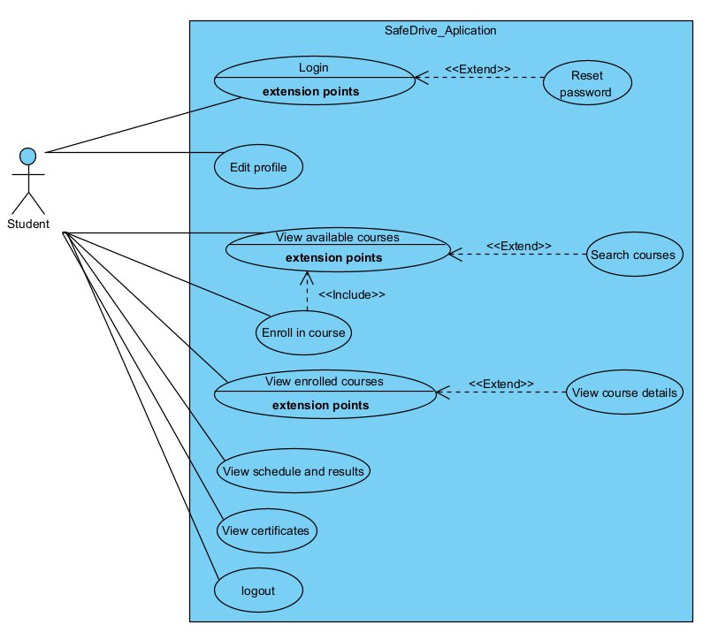

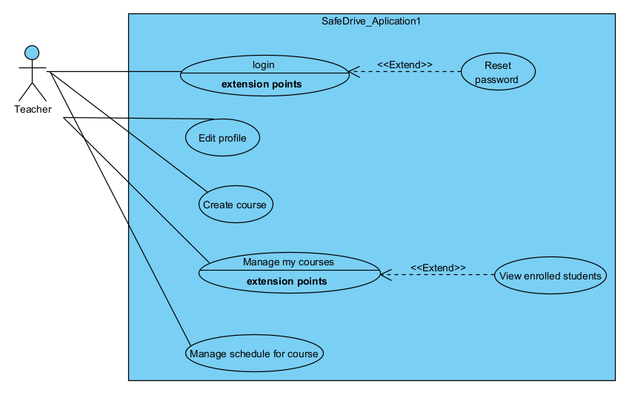

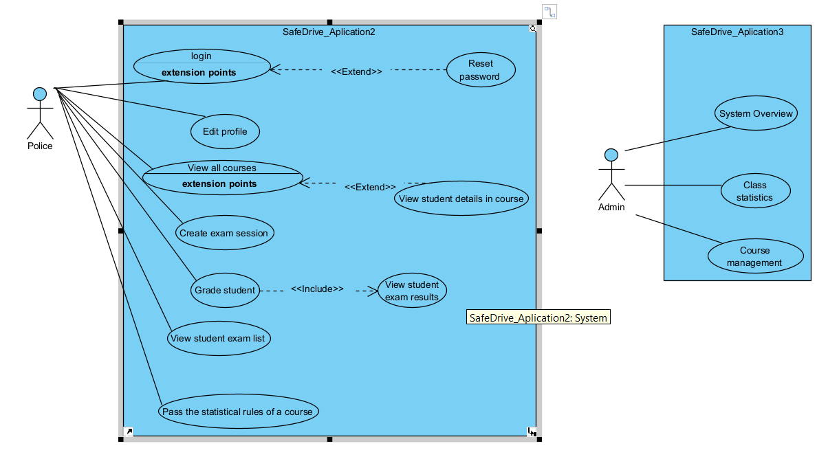

#### b. Descriptions (done)

| **ID** | **Feature** | **Use Case** | **Use Case Description** |
| --- | --- | --- | --- |
| 01 | Admin | Manage Courses | Delete and view all courses in the system.. |
| 02 | View System Statistics | View overall dashboard, system overview, and class statistics. |
| 03 | Student | Register/Login | Register a new account or login to the system. |
| 04 | Manage Profile | Update personal profile information. |
| 05 | Enroll in Courses | View available courses and enroll in preferred ones. |
| 06 | View Exam Info | View exam schedules and results. |
| 07 | View Certificates | View and download earned certificates. |
| 08 | Teacher | Manage Courses | Create and update courses. |
| 09 | Manage Course Schedule | Manage schedule for each course. |
| 10 | Manage Student List | View and manage lists of enrolled students. |
| 11 | Police | View Student Data | View all courses and student data. |
| 12 | Grade Exams | Grade student exams and enter scores. |
| 13 | Organize Exam Sessions | Schedule and organize exam sessions. |
| 14 | View Exam Details | View details of each student's exam |
| 15 | Generate Statistics | Generate pass rate statistics for exams. |

## 2. Overall Functionalities

### c2.1 Screens Flow (chưa làm)

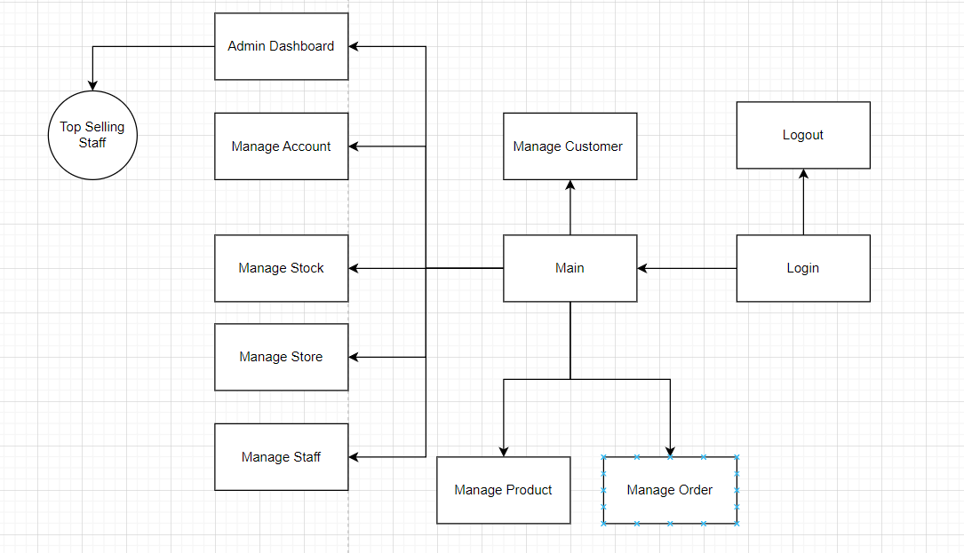

### 

### 

### 2.2 Screen Descriptions (chưa làm)

| **#** | **Feature** | **Screen** | **Description** |
| --- | --- | --- | --- |
| 1 | User Login | Login | Users log in using their email and password to access the system. |
| 2 | Student Dashboard | StudentHome | Main interface for students: view courses, track progress, exam results, and certification status. |
| 3 | Teacher Dashboard | TeacherHome | Main interface for teachers: manage courses, view registered students, and enter exam results. |
| 4 | Traffic Police Dashboard | PoliceHome | Main interface for traffic police officers: approve exams, manage and issue certificates. |
| 5 | Admin Login | Login | Admin logs into the system with admin credentials. |
| 6 | Admin Dashboard | AdminHome | Main dashboard for administrators to manage users, settings, and monitor system activity. |
| 7 | User Management | ManageUsers | Admin can add, edit, or delete users (students, teachers, traffic police). |
| 8 | Course Management | ManageCourses | Teachers can create and edit courses, including schedule, duration, and course details. |
| 9 | Registration Management | ManageRegistrations | Students register for courses and exams; teachers approve participation lists. |
| 10 | Exam Management | ManageExams | Traffic police officers manage exam scheduling, assign exam rooms, and supervise the exam process. |
| 11 | Result Management | ManageResults | Teachers enter exam scores; the system automatically determines pass/fail status. |
| 12 | Certificate Management | ManageCertificates | Traffic police issue certificates to students who passed; certificates include unique codes and expiry dates. |
| 13 | Notification Management | Notifications | System sends automated notifications (course schedule, exam dates, results, certificate status) to users. |
| 14 | Reports & Statistics | ReportDashboard | Admin and traffic police can view statistics such as number of registrations, pass rates, and issued certificates by class, school, or course. |
| 15 | Profile Management | UserProfile | All users can view and update their personal information, password, and contact details. |

### 2.3 Screen Authorization (chưa làm)

| **#** | **Screen** | **Admin** | **Manager** |
| --- | --- | --- | --- |
| 1 | Log in | X | X |
| 2 | Home | X | X |
| 3 | Customer Management | X | X |
| 4 | Order Management | X | X |
| 5 | Product Management | X | X |
| 6 | ManageStaff | X |  |
| 7 | Manage Account | X |  |
| 8 | Admin Dashboard | X |  |

### System High Level Design

### 3.1 Database Design

#### Database Schema

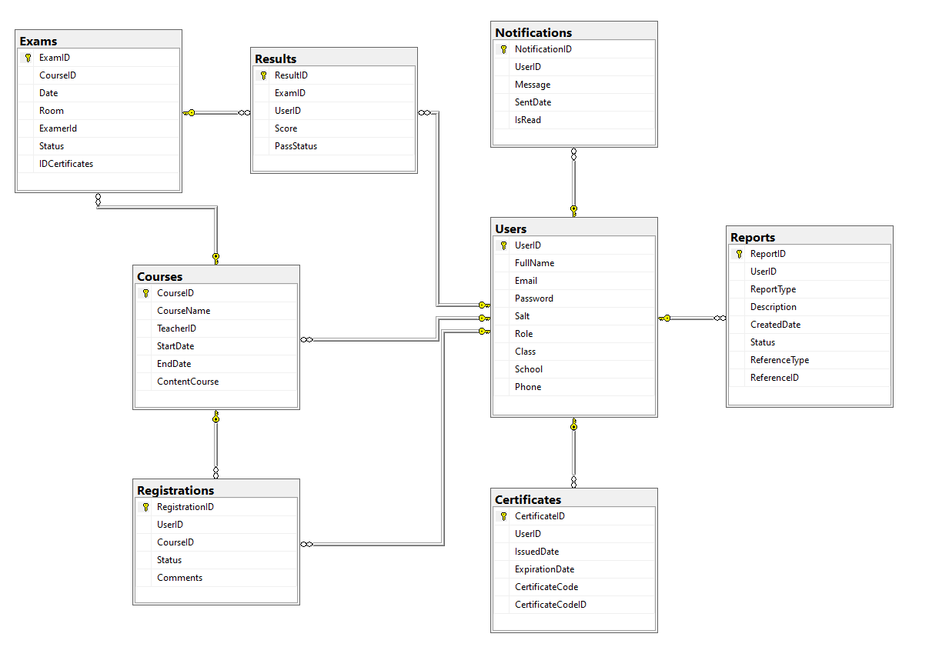

#### b. Table Descriptions

| **No** | **Table** | **Description** |
| --- | --- | --- |
| 01 | Users | - Manages user accounts with fields for UserID, FullName, Email, Password, Role, etc.  - Primary key: **UserID** |
| 02 | Courses | - Stores course information with fields for CourseID, CourseName, TeacherID, StartDate, etc.  - Primary key: **CourseID** |
| 03 | Registrations | - Manages course registration with fields for RegistrationID, UserID, CourseID, etc.  - Primary key: **RegistrationID** |
| 04 | Exams | - Stores exam information with fields for ExamID, CourseID, Date, Room, etc.  - Primary key: **ExamID** |
| 05 | Results | - Stores exam results with fields for ResultID, ExamID, UserID, Score, etc.  - Primary key: **ResultID** |
| 06 | Certificates | - Manages issued certificates with fields for CertificateID, UserID, IssueDate, etc.  - Primary key: **CertificateID** |
| 07 | Reports | - Stores reports with fields for ReportID, UserID, Description, ReferenceType, etc.  - Primary key: **ReportID** |
| 08 | Notifications | - Stores user notifications with fields for NotificationID, UserID, Message, IsRead, etc.  - Primary key: **NotificationID** |

4. Class diagram,

*4.1. 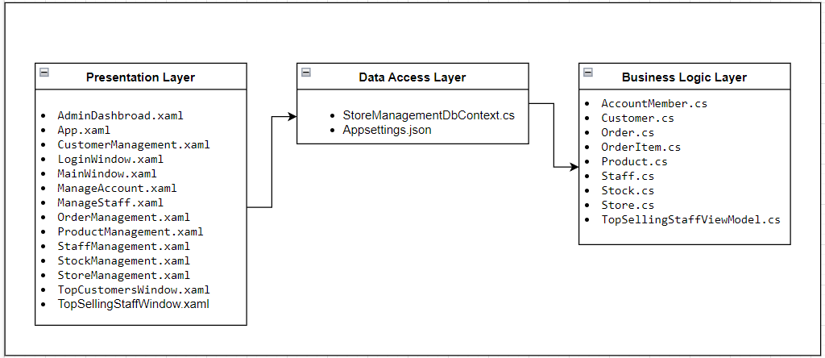*

*4.2. Class diagram*

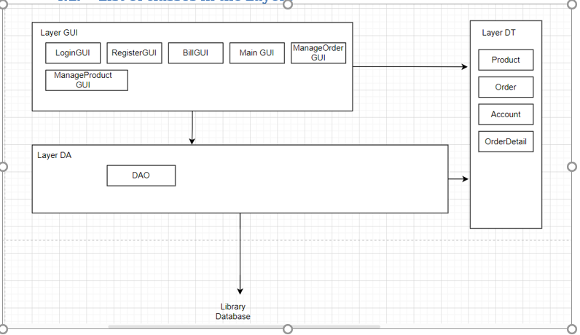

# II. Requirement Specifications (OPTIONAL)

## 1. Common Functions

### 1.1 UC1_ Login

**Functional Description Template**

| ID and Name: | UC-1_ User Login | | |
| --- | --- | --- | --- |
| Created By: | HE18714  Nguyễn Đức Phúc | Date Created: | 23/7/2025 |
| Primary Actor: | User (Admin/Staff) | Secondary Actors: |  |
| Description: | This use case describes the authentication process for users by verifying their email and password. | | |
| Trigger: | User attempts to log in. | | |
| Preconditions: | PRE-1: User has an existing account. | | |
| Postconditions: | * POST-1: User is logged into the system and can access authorized functionalities. | | |
| Normal Flow: | 1. User enters an email and password. 2. System verifies credentials. 3. If valid, user is logged in; otherwise, an error message is displayed | | |
| Alternative Flows: | AF-1: User clicks "Forgot Password", redirects to Password Reset page. | | |
| Exceptions: | EX-1: Database connection error. | | |
| Priority: | High | | |
| Frequency of Use: | Frequently used by all users. | | |
| Business Rules: | BR- 1: Default admin account: MemberID is “Admin” and password is “123456”.  BR- 2: Default staff account: MemberID is “Staff1” and password is “123456”. | | |
| Other Information: | N/A | | |
| Assumptions: | N/A | | |

### 1.2 UC2_Customer Manage

a. Functional Description

| ID and Name: | UC-2_ Student Dashboard | | |
| --- | --- | --- | --- |
| Created By: | HE18714  Nguyễn Đức Phúc | Date Created: | 23/7/2025 |
| Primary Actor: | Student | Secondary Actors: | None |
| Description: | Student views courses, tracks progress, exam results, and certification status. | | |
| Trigger: | Student logs into the system and accesses the dashboard. | | |
| Preconditions: | Student must be logged in. | | |
| Postconditions: | Dashboard information is displayed to the student. | | |
| Normal Flow: | 1. Student logs into the system. 2. The system displays the "StudentHome" dashboard. 3. The dashboard shows enrolled courses, progress status. 4. Student views exam results. 5. Student views certificate status.   . | | |
| Alternative Flows: | 3a. If the student has no enrolled courses, the system displays a message: “No courses enrolled.” | | |
| Exceptions: | E1. Network failure → Display error message: “Unable to load dashboard. Please try again later.”  E2. Session timeout → Redirect to login page | | |
| Priority: | High | | |
| Frequency of Use: | Usually | | |
| Other Information: | N/A | | |
| Assumptions: | N/A | | |

### 1.3 UC3_Order Manage

| ID and Name: | UC3_TeacherDashboard | | |
| --- | --- | --- | --- |
| Created By: | HE18714  Nguyễn Đức Phúc | Date Created: | 23/7/2025 |
| Primary Actor: | Teacher | Secondary Actors: | None |
| Description: | Teachers can manage courses, view registered students, and enter exam results. | | |
| Trigger: | Teacher clicks on the “Teacher Dashboard” button. | | |
| Preconditions: | Teacher must be logged in. | | |
| Postconditions: | Teacher views and manages courses and student records. | | |
| Normal Flow: | 1. Teacher logs into the system. 2. Teacher navigates to Teacher Dashboard. 3. System displays courses assigned to the teacher. 4. Teacher selects a course to view student list. 5. Teacher can enter exam scores for students | | |
| Alternative Flows: | Teacher chooses not to enter results but only views student li | | |
| Exceptions: | Network failure when submitting results.  Unauthorized access attempt. | | |
| Priority: | High | | |
| Frequency of Use: | Frequent | | |
| Other Information: | Teachers can also view basic statistics per course. | | |
| Assumptions: | Teachers are trained in using the system. | | |

### 1.4 UC4_Product Manage

a. Functional Description

| ID and Name: | UC4 – Traffic Police Dashboard | | |
| --- | --- | --- | --- |
| Created By: | HE18714  Nguyễn Đức Phúc | Date Created: | 23/7/2025 |
| Primary Actor: | Traffic Police Officer | Secondary Actors: | none |
| Description: | Officers manage exams and issue certificates. | | |
| Trigger: | Officer clicks on “Police Dashboard”. | | |
| Preconditions: | Officer is authenticated. | | |
| Postconditions: | Officer is authenticated. | | |
| Normal Flow: | 1. Officer logs in. 2. Clicks “Police Dashboard”. 3. Views upcoming and past exams. 4. Accesses and issues certificates to passed students. | | |
| Alternative Flows: | Officer only views exams but skips issuing certificates. | | |
| Exceptions: | Certificate generation fails due to invalid data.  Session timeout.  . | | |
| Priority: | High | | |
| Frequency of Use: | Usually | | |
| Other Information: | Linked with result management and certificate modules. | | |
| Assumptions: | Officers have permission to view student data. | | |

### 1.5 UC5_Staff Manage

a. Functional Description

| ID and Name: | UC5 – Admin Login | | |
| --- | --- | --- | --- |
| Created By: | HE18714  Nguyễn Đức Phúc | Date Created: | 23/7/2025 |
| Primary Actor: | Admin | Secondary Actors: | none |
| Description: | Admin logs into the system using admin credentials. | | |
| Trigger: | Admin accesses the login screen. | | |
| Preconditions: | Admin accesses the login screen. | | |
| Postconditions: | SAdmin is redirected to the Admin Dashboard. | | |
| Normal Flow: | * Admin enters username and password. * Clicks “Login”. * System authenticates credentials. * System redirects admin to dashboard. | | |
| Alternative Flows: | Forgot password → uses recovery flow. | | |
| Exceptions: | Incorrect credentials.  Account locked after multiple failures. | | |
| Priority: | High | | |
| Frequency of Use: | Every system access | | |
| Other Information: | Login is audited | | |
| Assumptions: | Admin accounts are pre-registered. | | |

### 1.6 UC6_Manage Account

| ID and Name: | UC6 – Admin Dashboard | | |
| --- | --- | --- | --- |
| Created By: | HE18714  Nguyễn Đức Phúc | Date Created: | 23/7/2025 |
| Primary Actor: | Admin | Secondary Actors: | none |
| Description: | Admin views and manages users, system settings, and activities. | | |
| Trigger: | Admin logs in successfully. | | |
| Preconditions: | Admin is authenticated. | | |
| Postconditions: | Admin has access to all admin functions. | | |
| Normal Flow: | * Admin accesses Admin Dashboard. * Views summary of user activities and reports. * Navigates to various management sections (users, courses, etc.). | | |
| Alternative Flows: | Admin accesses only specific modules, not full dashboard.. | | |
| Exceptions: | * Module load fails due to service error. | | |
| Priority: | High | | |
| Frequency of Use: | Usually | | |
| Other Information: | All admin activity logged. | | |
| Assumptions: | Admin roles determine visibility of features. | | |

### 1.7 UC7_Manage Account

| ID and Name: | **UC7 – Manage Users** | | |
| --- | --- | --- | --- |
| Created By: | HE18714  Nguyễn Đức Phúc | Date Created: | 23/7/2025 |
| Primary Actor: | Admin | Secondary Actors: | None |
| Description: | Admin can add, edit, or delete users (teachers, traffic police, students). | | |
| Trigger: | Admin clicks on “Manage Users”. | | |
| Preconditions: | Admin must be logged in. | | |
| Postconditions: | User data is updated as per admin’s actions. | | |
| Normal Flow: | Admin opens Manage Users.  Views list of all users.  Adds a new user / edits user info / deletes a user.  Saves changes. | | |
| Alternative Flows: | Admin cancels user creation mid-way. | | |
| Exceptions: | Duplicate usernames.  Deleting users with active records. | | |
| Priority: | High | | |
| Frequency of Use: | Usually | | |
| Other Information: | Supports role-based filtering. | | |
| Assumptions: | Only admins with “User Manager” rights can access. | | |

# 

| ID and Name: | **UC7 – Manage Users** | | |
| --- | --- | --- | --- |
| Created By: | HE18714  Nguyễn Đức Phúc | Date Created: | 23/7/2025 |
| Primary Actor: | Admin | Secondary Actors: | None |
| Description: | Admin can add, edit, or delete users (teachers, traffic police, students). | | |
| Trigger: | Admin clicks on “Manage Users”. | | |
| Preconditions: | Admin must be logged in. | | |
| Postconditions: | User data is updated as per admin’s actions. | | |
| Normal Flow: | Admin opens Manage Users.  Views list of all users.  Adds a new user / edits user info / deletes a user.  Saves changes. | | |
| Alternative Flows: | Admin cancels user creation mid-way. | | |
| Exceptions: | Duplicate usernames.  Deleting users with active records. | | |
| Priority: | High | | |
| Frequency of Use: | Usually | | |
| Other Information: | Supports role-based filtering. | | |
| Assumptions: | Only admins with “User Manager” rights can access. | | |

# 

# III. Design Specifications

1. Student logs in with the designated account



2. Student screen after logging in



3.Students edit personal information

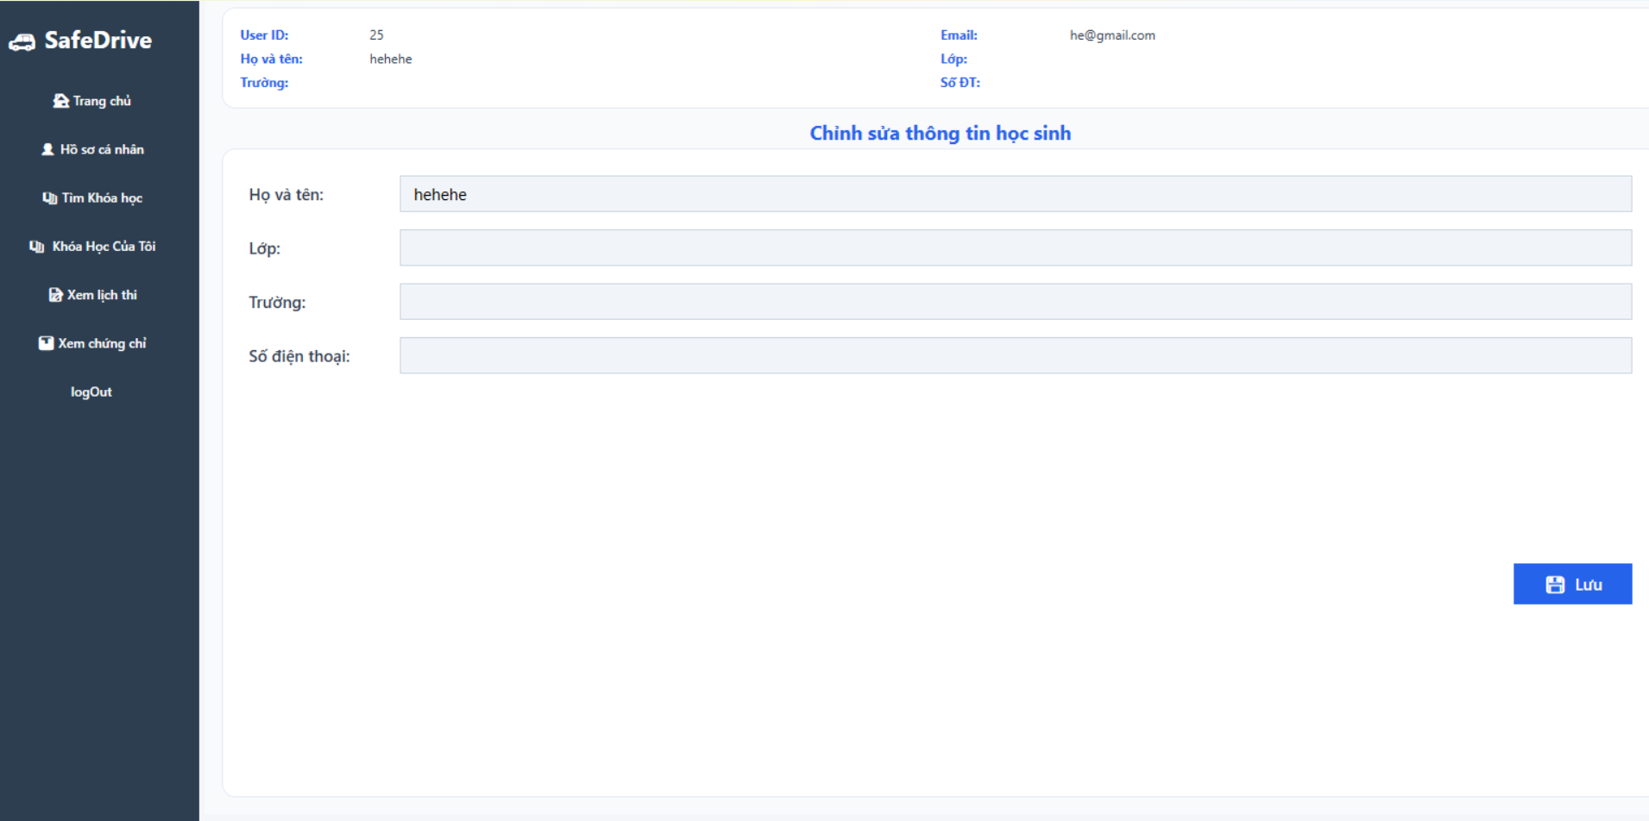

4. Students view course list, register for courses, search for courses

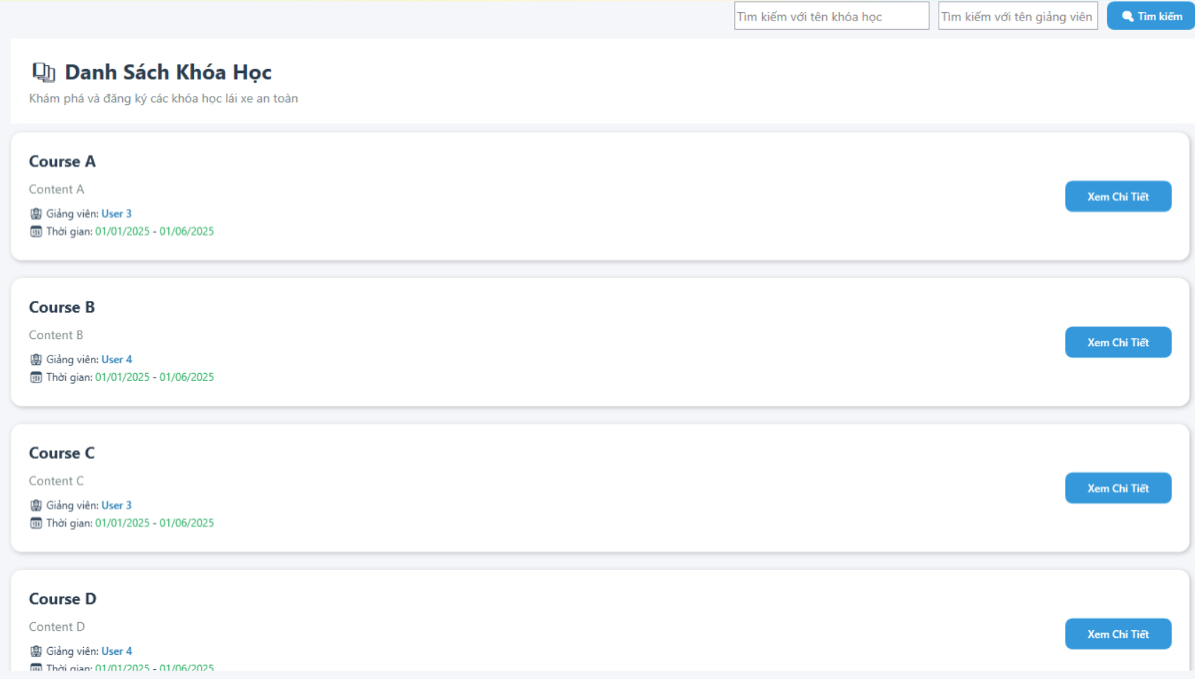

5. Students view the list of registered

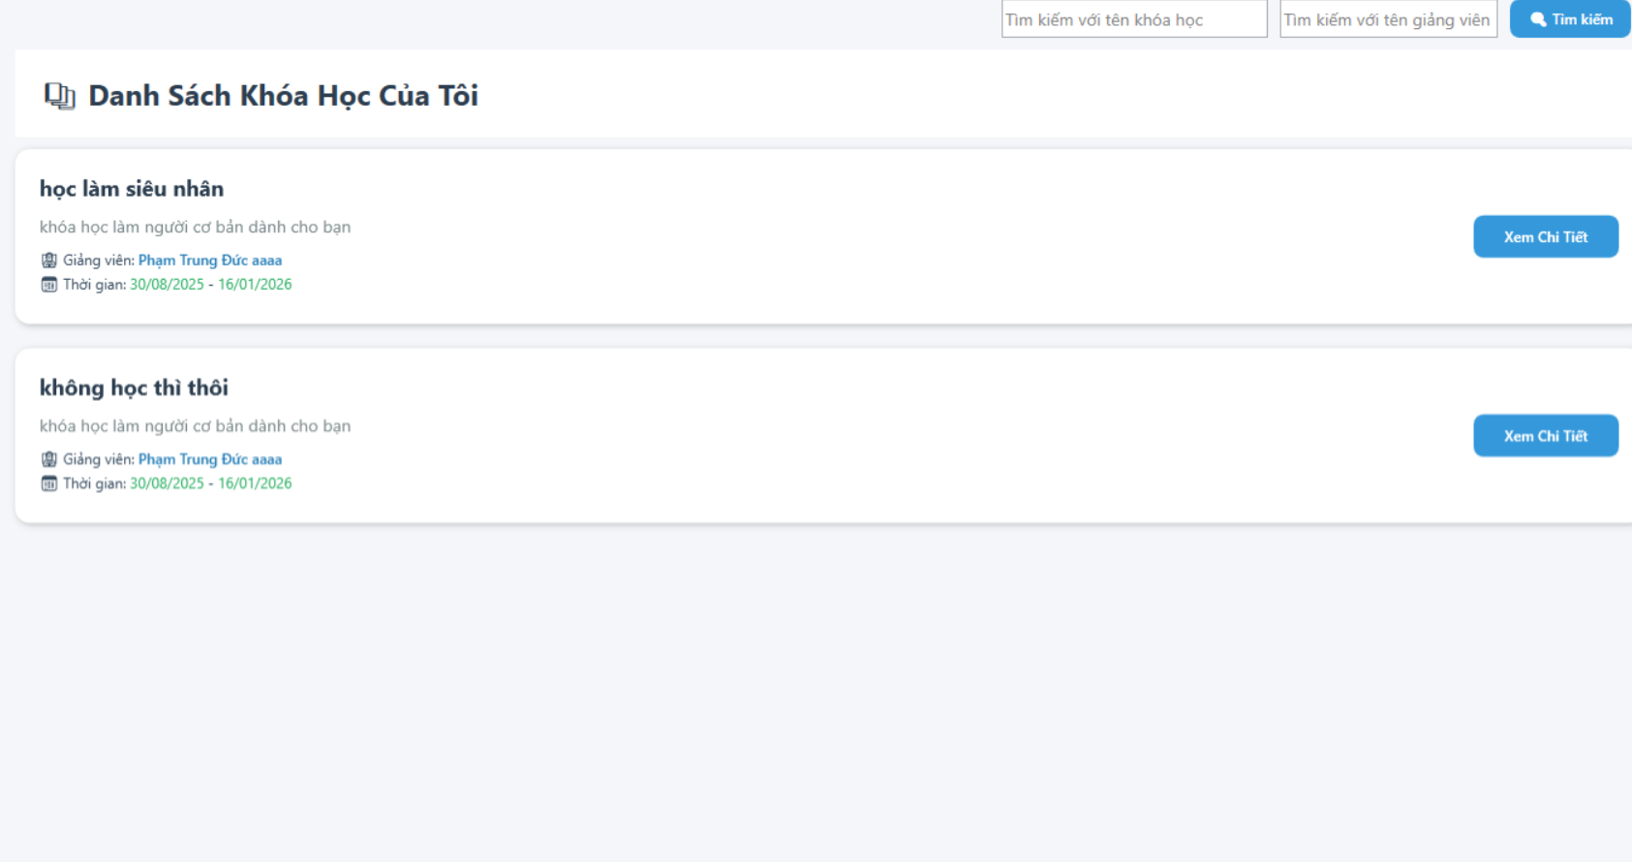

**6. Students view exam schedule**

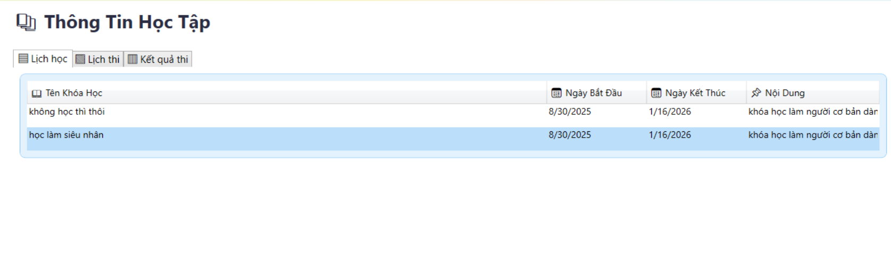

**7.** students view certificates

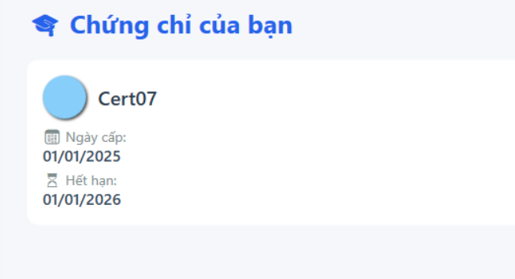

8. Teacher edit their profile

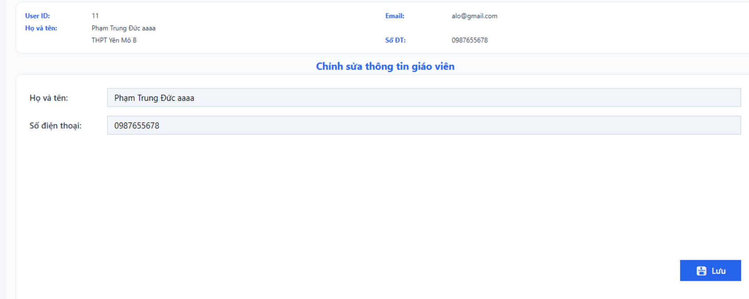

9. Teacher mangage their courses

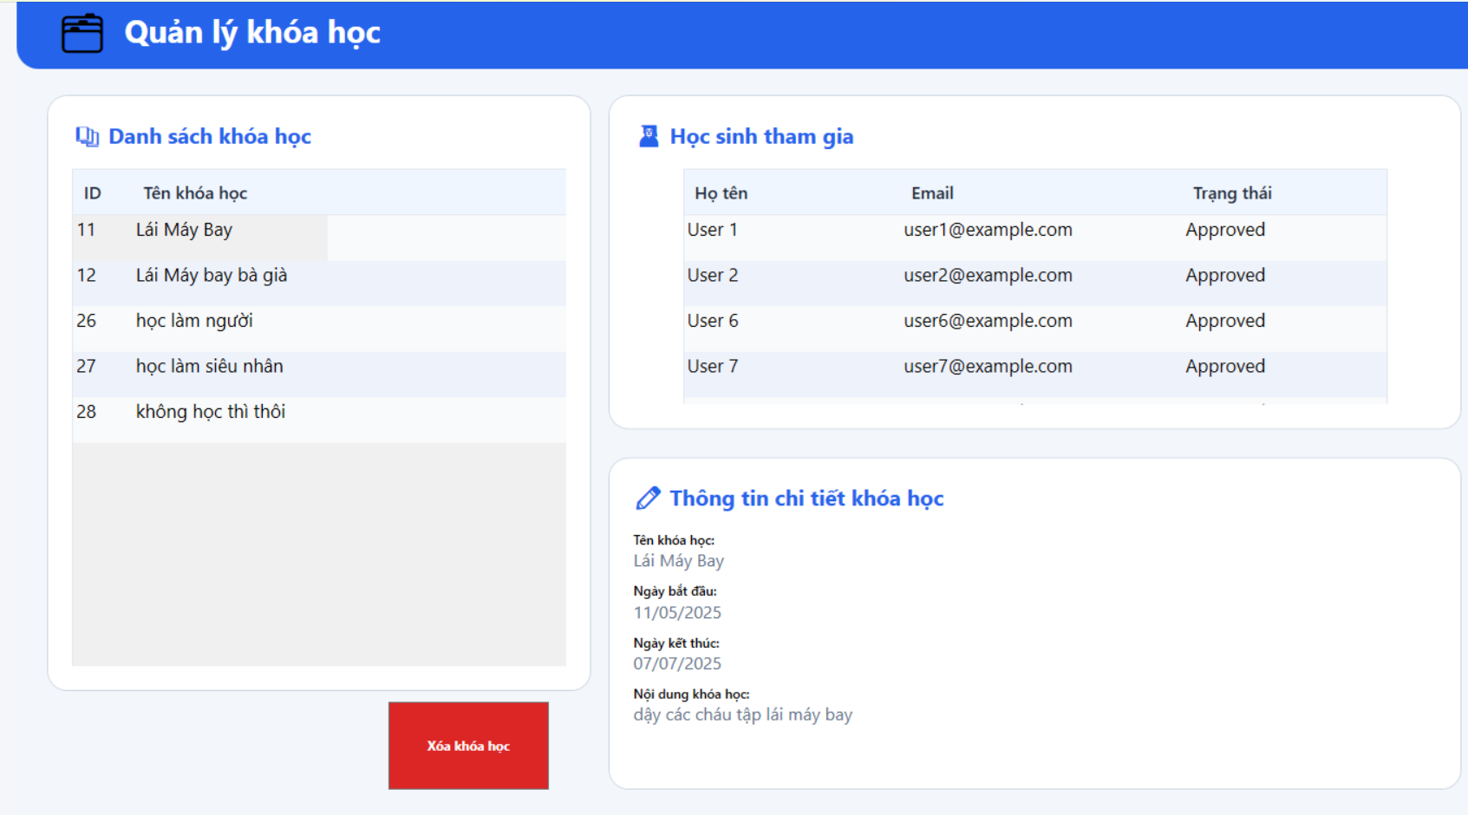

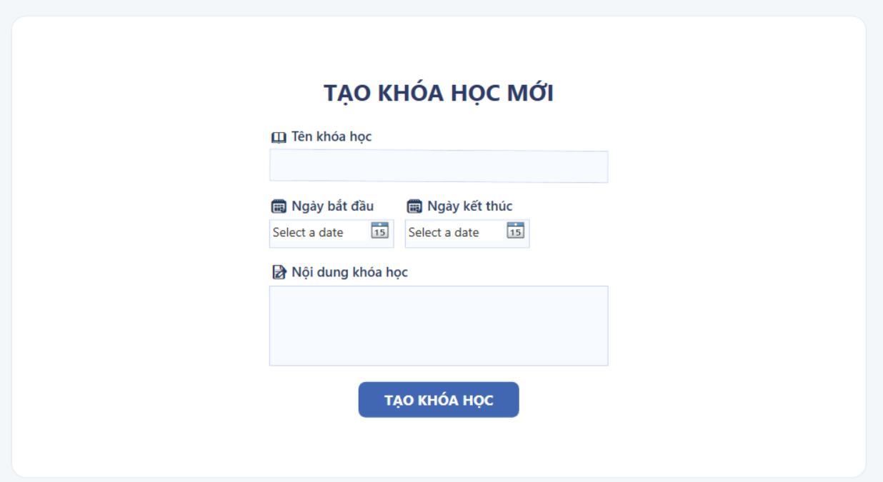

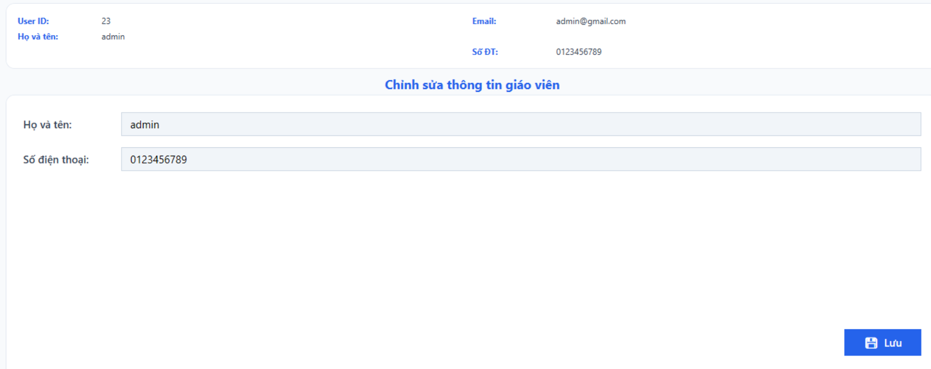

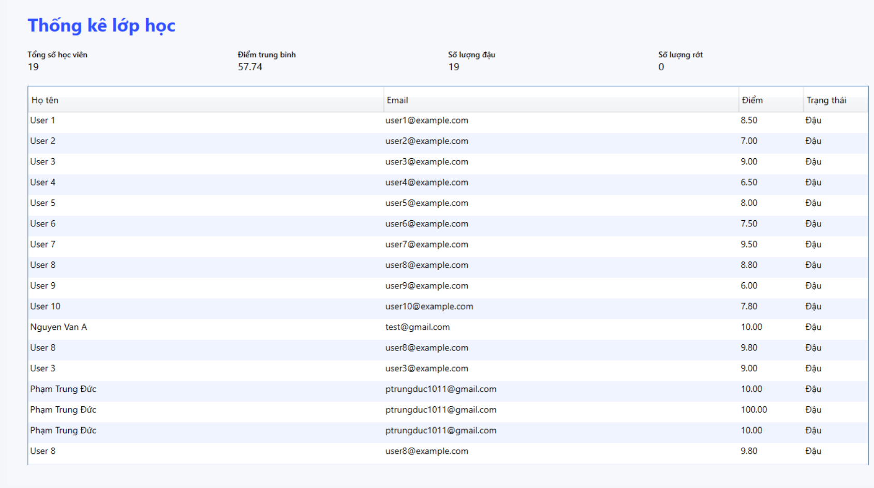

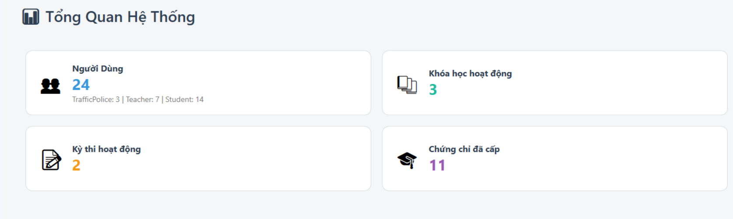

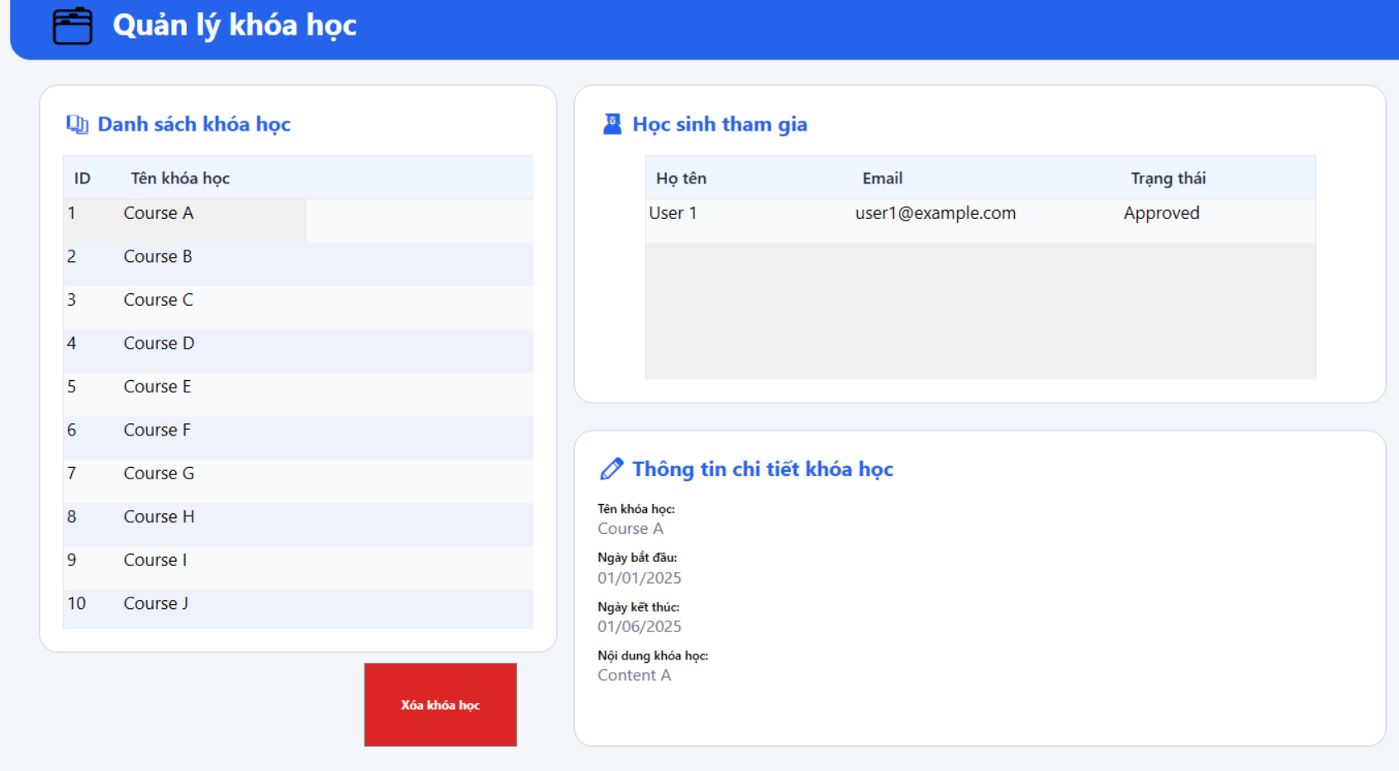

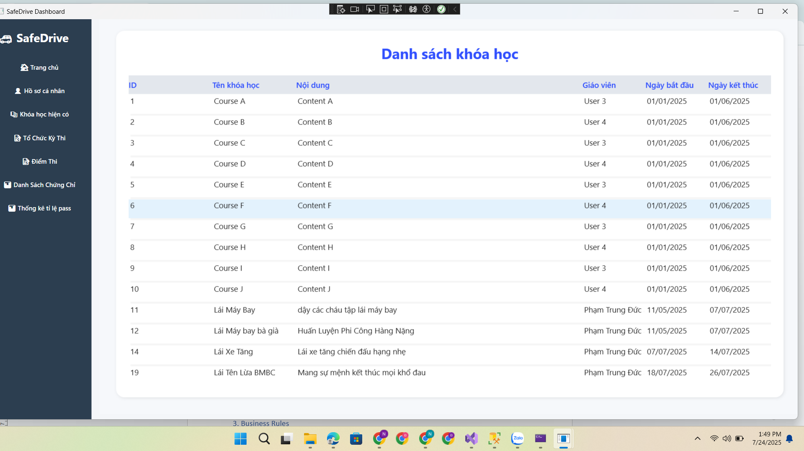

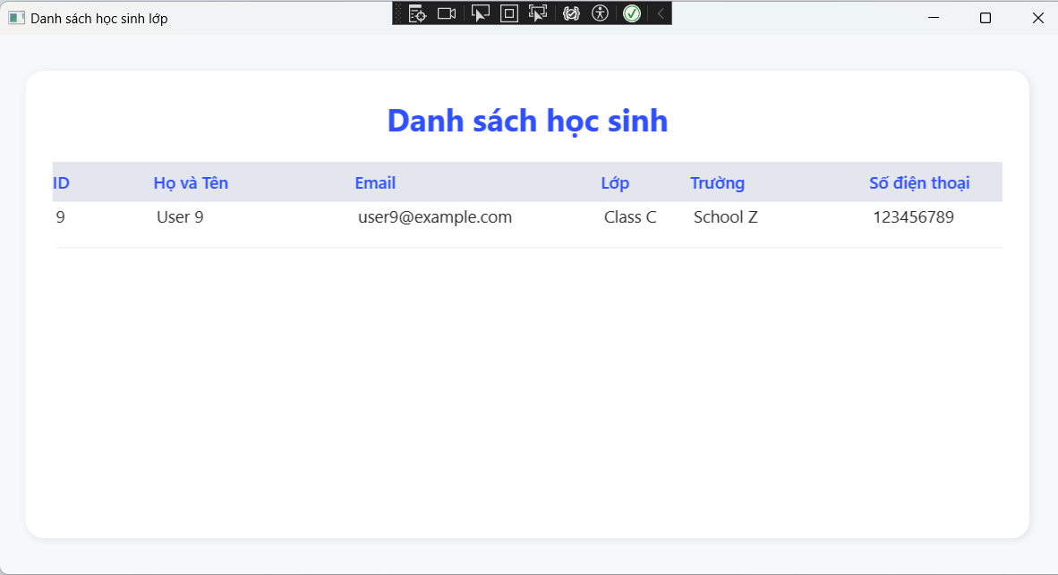

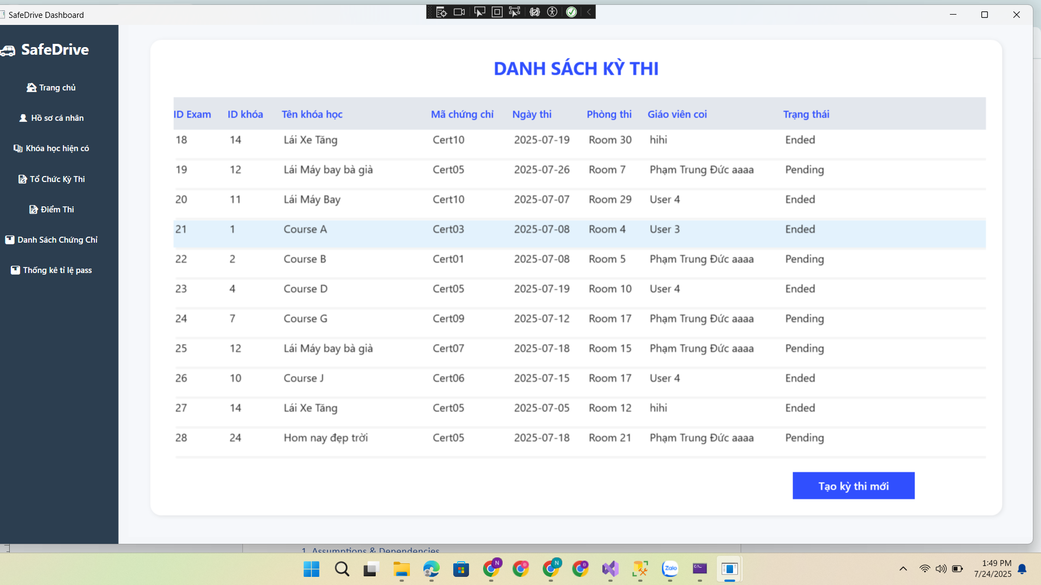

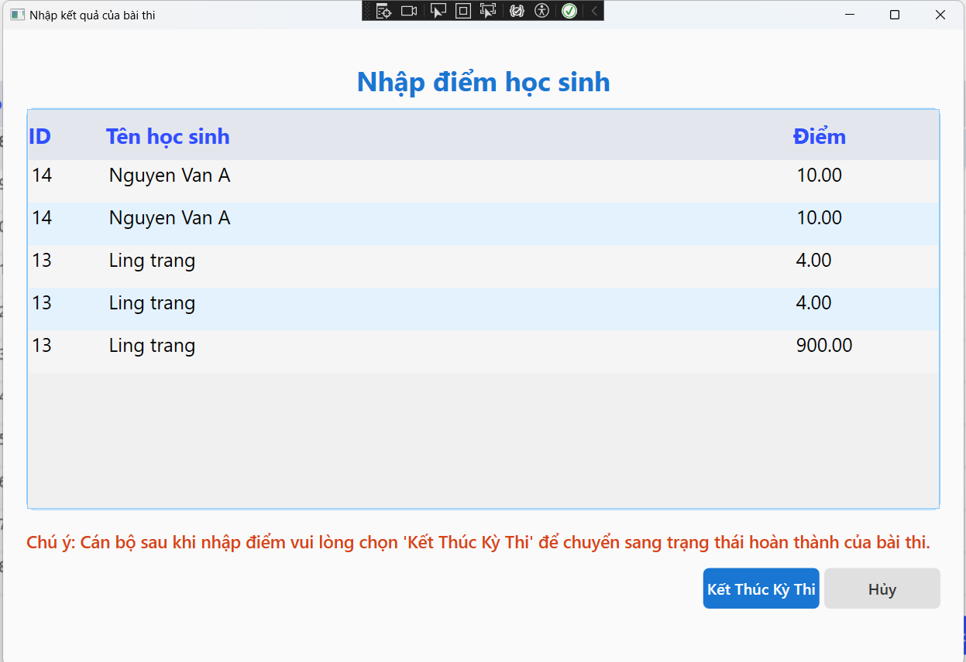

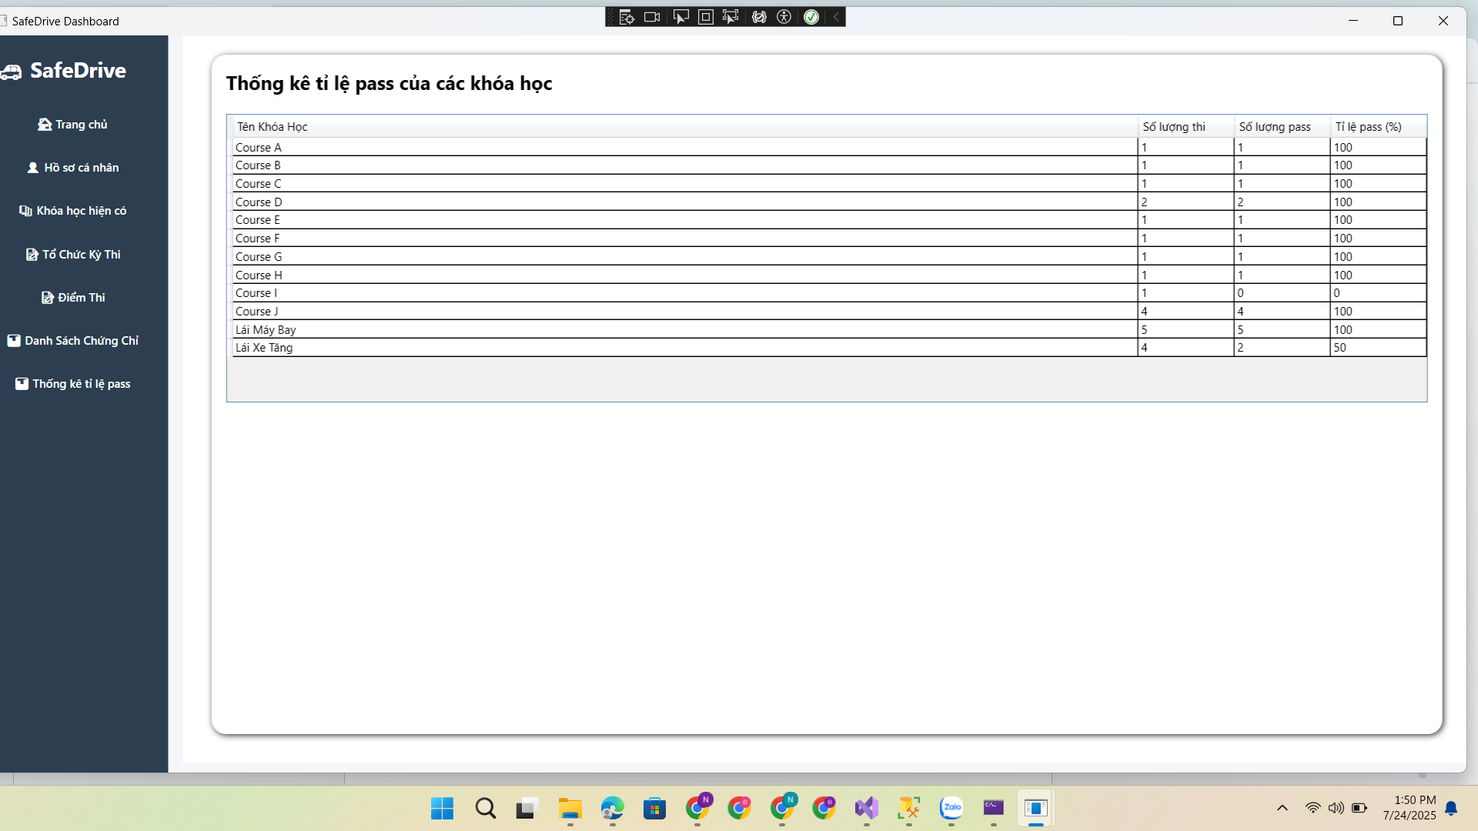

# IV. Appendix

## 1. Assumptions & Dependencies

AS-1: The system will be used within the organization's internal network.

DE-1: Users have basic knowledge of using Windows applications.

## 2. Limitations & Exclusions

L-E : The system will not support mobile platforms in the current version..

## 3. Business Rules

## 

BR- 1: Default admin account: MemberID is “Admin” and password is “@admin123”.

BR- 2: Default staff account: MemberID is “Staff” and password is “@staff123”.